Core Assignment 8.2 Cold War Name ___________________________
Level 2
Define suburbs and their significance in the 1950s.
_______________________________________________________________________________________________________________________________________________________________________________________________________________________________________________________________
Identify at least three specific examples of nonviolent protest during the Civil Rights movement.
_______________________________________________________________________________________________________________________________________________________________________________________________________________________________________________________________
Level 3
Complete the following chart using leaders from at least two different civil rights movements:
Name of Civil Rights Leader | Tactics used to achieve their goals | Rate their effectiveness on a scale from 1-10 | Justification for rating

 | ¹⁹⁴⁰ | ¹⁹⁵¹ | ¹⁹⁵⁹
^{GNP}  (total value of all goods/services produced) | ^{43.9} | ^{85.6} | ^{101.6}
^{Average Income}  (full time worker) | ^{1,299} | ^{3,217} | ^{4,594}
^{Unemployment}  ^{Rate} | ^{14.6} | ^{3.3} | ^{5.5}

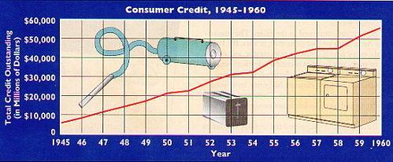
Interpret the data presented in the charts above regarding the postwar American economy. What does this data say about the state of the American economy? What are the economy’s strengths and weaknesses? How can one account for some potential contradictory data?
__________________________________________________________________________________________________________________________________________________________________________________________________________________________________________________________________________________________________________________________________________________________________________________________________________________________________________________________________________________________________________________________________________________________________________________________________________________________________________________________________________________________________________________________________________________________________________________________________________________________________________________________________________________

Level 4
Looking back, what are some factors that made the Civil Rights movement of the 1960s successful? Additionally, remark upon the lingering effects of the Civil Rights movement on present-day America politically and socially.
_________________________________________________________________________________________________________________________________________________________________________________________________________________________________________________________________________________________________________________________________________________________________________________________________________________________________________________________________________________________________________________________________________________________________________________________________________________________________________________________________________________________________________________________________________________________________________________________________________________________________________________________________________________________________________________________________________________________________________________________________________________________________________________________________________________________________________________________________________________________________________________________________________________________________________________________________________________________________________________________________________________________________________________________________________________________________________________________________________________________________________________________________________________________________________________________________________________________________________________________________________________________________________________________________________________________________________________________________________________________________________________________
Level 4  10pts | Level 3.5 9.5pts | Level 3 9pts | Level 2.5 8pts | Level 2  7pts | Level 1.5 6.5pts | Level 1 6pts
Can analyze and infer information from class as well as information beyond classroom instruction | Can do Level 3 with some Level 4 | Can apply more complex details and concepts from the Cold War as taught in class | Can do Level 2 with some Level 3 | Can relate simple details from the Cold War as taught in class | Can do Level 1 with some Level 2 | Struggles with basic identification of Cold War terms

