The Aggressors’ Aggressions
Japan
* Many in Japan sought to _____________
* Army seized Chinese area of ___________________
-- Wanted resources for itself
-- Japanese _________________ ordered an end to operation
-- Military _______________
* Military gained control of Japanese government
* Public _________________ nationalist goals
Italian Fascism
* Fascism – system of government that stressed the __________ of the __________ (“I will protect you…”)
-- Rights and concerns of ______________ dismissed
* Mussolini used anger at Versailles and fear of communists to create a ____________________
-- Outlawed ________________
-- Took away civil liberties
-- Government took control of schools, _________________, etc
Italy Invades Ethiopia
* Ethiopia former colony of _______________
* Mussolini wanted to regain the ______________ ______________
* Ethiopians asked the _____________ ___ _____________ for help
-- League too afraid of conflict, was unwilling to help
-- _______, too, afraid to take a stand
Hitler’s Rise to Power
* Anger at __________________ led him to politics
* Joined National Socialists, or _____________
-- Gifted public speaker, became leader of movement
* Led failed __________ in 1923; five-year prison sentence
* Used discontent, vision of _______________ ______________
-- Also used anti-___________, pro-___________ stance, rhetoric
* Gained power _______________
* Argued for German “___________ __________”
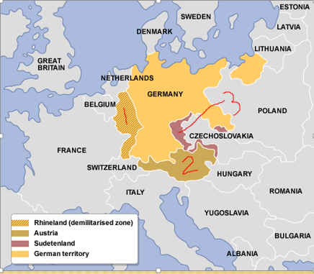
German Expansion
* 1. _______________
-- Hitler defied Treaty of Versailles by putting __________ in the Rhineland
-- France freaked out, but unwilling to take _________ _________
-- German troops remained in the Rhineland
-- What has Hitler learned from this episode?
* 2. The Anschluss (_________)
-- Hitler goal - ___________ all ethnic Germans in his “reich”
-- Worked to force Austria to ___________ with Germany
-- Austrian government ___________
-- Hitler sent in __________
-- Neighbors wrote strongly worded _______________
* 3. The ____________________
-- Small, German-speaking part of ___________________
-- Hitler threated _____________ _______________
-- Munich Conference – Hitler assured _____ and __________ he would not expand any further if he got Sudetenland
-- _________________ - giving someone what they want just to shut them up
-- Only make the aggressor more ________________

* August 1939 – Nazi-Soviet ______-_______________ Pact
* _____________ ___, _______ - Germany and USSR invade Poland, WWII starts

Axis Spreading – summarize what the Axis powers did in each area (p. 748)
-- Belgium/Netherlands –

-- France –

-- Britain

-- East Asia –

US Attitude – WWII (pre-1941)
American Isolationism
* How did WWI benefit the US?
* US unwilling to join ___________ of ____________
-- Represents US desire to stay out of ____________ ___________
* _______________ view – only way to avoid conflict is to limit involvement in the rest of the world
* _______________ view – only way to avoid conflict is to actively prevent conflict elsewhere
* Neutrality Act of 1935 – sought to avoid getting dragged into another ________________ _________
Balancing Isolationism and Intervention
* _________________ _______________ making FDR nervous
-- Halted arms sales to _____________
* Staying 100% neutral only helped _________________
* As aggression increased, FDR moves to get more involved, caring less about ________________ _________________
* Japanese invasion of ______________ in 1937 led FDR to speak out
-- Compared spread of war to spread of _____________ (need for quarantine)

Preparing for War
* Growing momentum for FDR’s interventionist _______________
* FDR’s steps toward _________________ (“all aid short of war”)
-- 1. _________-and-__________ - countries could buy war goods from US if they paid ___________ and picked up own goods
-- 2. ___________ __________ - traded 50 destroyers to _______
for 8 military bases in Caribbean
-- 3. ___________ __________ - Sept. 1940 – drafted men into military service (US _______ ____ _______ yet)
-- 4. _________-_________ Act – sent weapons to GB even though they couldn’t _______
Japan Attacks Pearl Harbor
* War with _________ more likely than war with ____________
* US embargoed _________ and _________ __________ to Japan
* Believed that any attack would occur in _______________
-- US wouldn’t fire first shot
* Pearl Harbor base in _____________ seen as too far away
-- But…Japan attacked with ___________ carriers and _________
* ______________ ____, ___________ - Japan attacks US naval forces at Pearl Harbor
* US ____________ __________ the next day

Term | Definition | Picture/Symbol
p. 759-762
WAVE/WASP/WAC

Rosie the Riveter

Manhattan Project

p. 794-796
Rationing

Civic Duty

Office of War Information

US Home Front Illustrated Dictionary

Battle in the Atlantic
Ways War is Going Poorly for Allies: | Turning Point:
War in the Soviet Union
Ways War is Going Poorly for Allies: | Turning Point:
North Africa and Italy
Ways War is Going Poorly for Allies: | Turning Point:

D-Day
What is it?
Where did it take place?
When?
What happened?
Result?

Battle of the Bulge?
What is it?
Where did it take place?
When?
What happened?
Result?
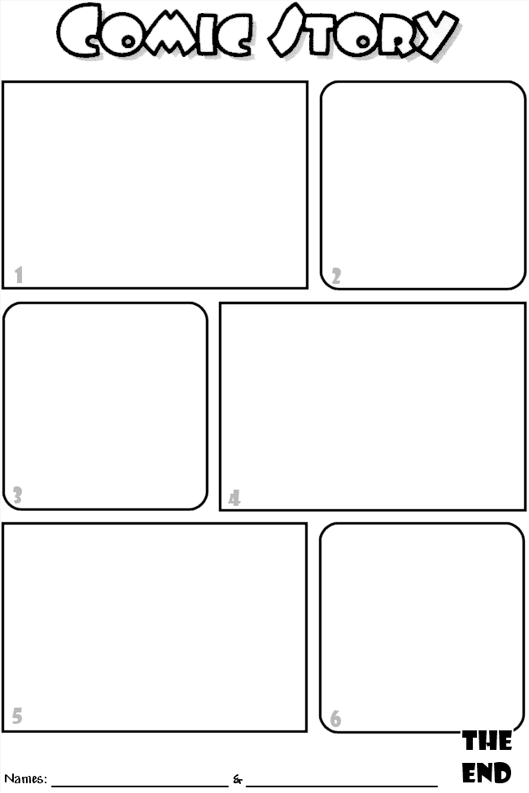
Why Do I Have to Prove My Loyalty?
Imagine yourself in the following situation, which was faced by many Japanese Americans in internment camps during World War II. Then answer the question. Be prepared to discuss and defend your answer.
You are one of over 100,000 West Coast Japanese Americans who were placed in internment camps in 1942. President Roosevelt, who said he feared internal violence and subversion during the early part of World War II, signed Executive Order 9066 authorizing the Army to evacuate “all persons of Japanese ancestry” – both citizen and alien alike. By November 1942 all West Coast Japanese Americans had been place in camps. The government claimed the action was necessary to protect the Japanese Americans as well as to ensure the safety of the country.
You are a Nisei, an American citizen by birth. You believe that being forced to live in a hastily built barracks surrounded by barbed-wire fence violates your civil rights. You know that some persons have been allowed to leave the camp after they promised to move into the interior of the country. To get permission to leave, you will have to complete a questionnaire that includes a loyalty oath in the form of this question:
Will you swear unqualified allegiance to the United States of America and faithfully defend the United States from any or all attack by foreign or domestic forces, and forswear any form of allegiance or obedience to the Japanese emperor, to any other foreign government, power, or organization?
You are not sure what to do. On the one hand, you question whether you can truthfully answer “yes” after the way the United States government has treated you. Also, by forswearing allegiance to Japan, you believe you would be indicating that you once had allegiance to Japan, which is not true. On the other hand, signing the oath seems to be the only way to get your family out of the camp, with its crowded living conditions and limited opportunities. Adding to your dilemma are reports of anti-Japanese sentiment in much of the country. You wonder how safe you and your family would be outside of the internment camp.
Question: How would you answer the loyalty question? Provide at least one reason for your answer.

p. 802
Yalta Conference
Plan for Germany:

Plan for Poland:

What potential problems could arise from these plans?

p. 807
What was the plan for post-war Japan?

Compare the post-war plans from WWI and WWII (use p. 607 for WWI plans if you need a reminder). What are some differences? What are some similarities?

